Cancel contract

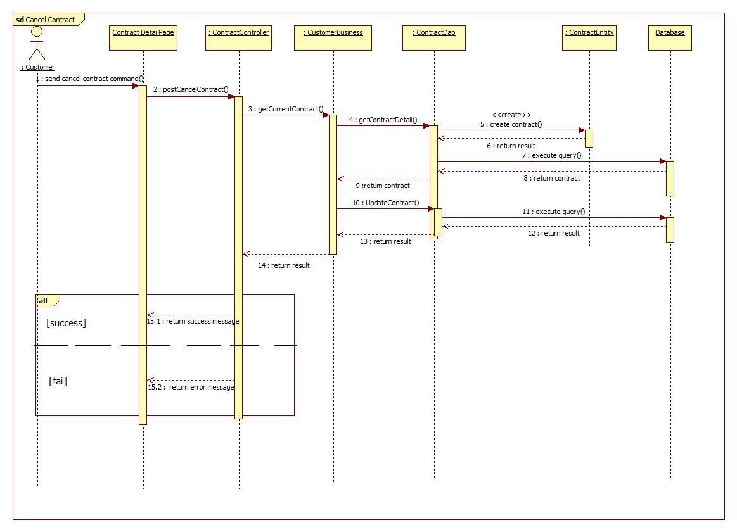

Renew contract

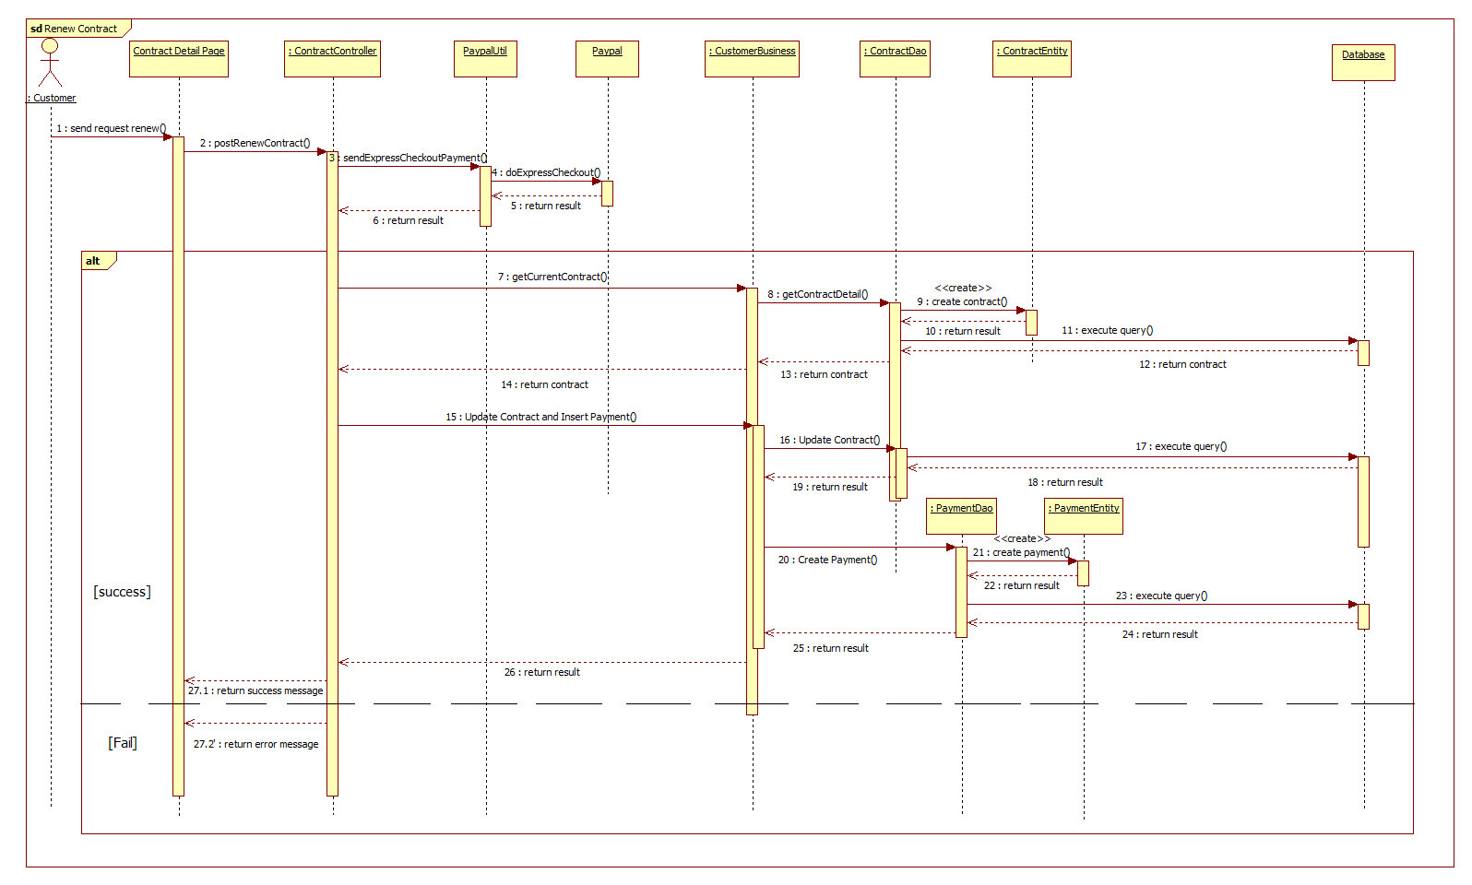

User interface design

1. Manage contract

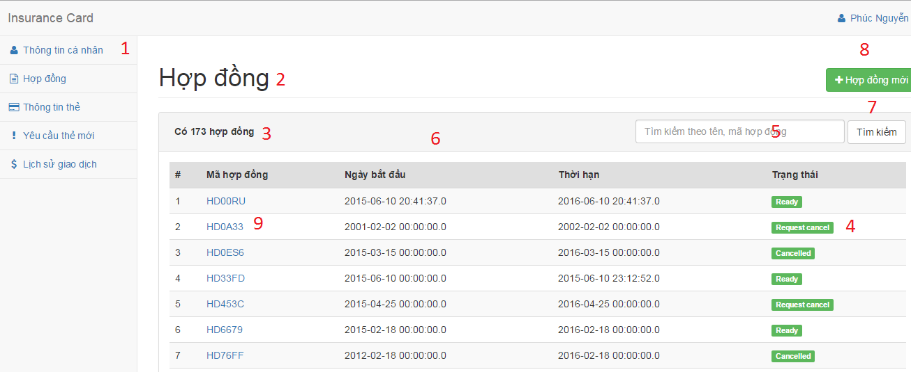

Fields

|  |  |  |  |  |  |  |  |
| --- | --- | --- | --- | --- | --- | --- | --- |
| **No** | **Field Name** | **Description** | **Read only** | **Mandatory** | **Control Type** | **Data Type** | **Length** |
| 1 | lblMenu | Navigation bar | Yes | Yes | Menu bar | N/A | N/A |
| 2 | lblTitle | Title of the page | Yes | Yes | Label | N/A | N/A |
| 3 | lblAmountContract | Number of available customer | Yes | No | Label | N/A | N/A |
| 4 | lblContractStatus | Status of contract | Yes | No | Label | N/A | N/A |
| 5 | txtSearch | Fill search keyword | No | Yes | Textbox | String | N/A |
| 6 | contractTable | Table of available contract | Yes | Yes | Table | N/A | N/A |

**Button/Hyperlinks**

|  |  |  |  |  |
| --- | --- | --- | --- | --- |
| **No** | **Function** | **Description** | **Validation** | **Outcome** |
| 7 | btnSearch | Search by input keyword | N/A | Transfer to search result page |
| 8 | btnCreate | Create new customer | N/A | Transfer to create new customer page |
| 9 | linkContractDetail | View contract detail | N/A | Transfer to contract detail page |

1. Contract Detail

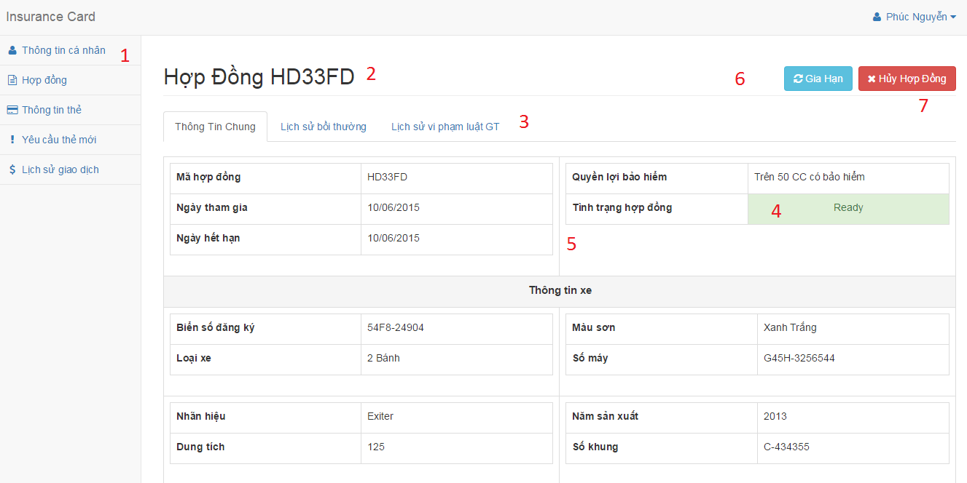

**Fields**

|  |  |  |  |  |  |  |  |
| --- | --- | --- | --- | --- | --- | --- | --- |
| **No** | **Field Name** | **Description** | **Read only** | **Mandatory** | **Control Type** | **Data Type** | **Length** |
| 1 | lblMenu | Navigation bar | Yes | Yes | Menu bar | N/A | N/A |
| 2 | lblTitle | Contract code | Yes | Yes | Label | N/A | N/A |
| 3 | txtTab | Information about contract | Yes | No | Tab | N/A | N/A |
| 4 | lblContractStatus | Status of contract | Yes | No | Label | N/A | N/A |
| 5 | txtInformation | Information about contract | No | Yes | Textbox | String | N/A |

**Button/Hyperlinks**

|  |  |  |  |  |
| --- | --- | --- | --- | --- |
| **No** | **Function** | **Description** | **Validation** | **Outcome** |
| 6 | btnRenew | Renew contract | N/A | Show popup to choose the reason cancel |
| 7 | btnCancel | Cancel contract | N/A | Show popup to provide new time for contract and the way to pay for renew contract |

1. Cancel contract

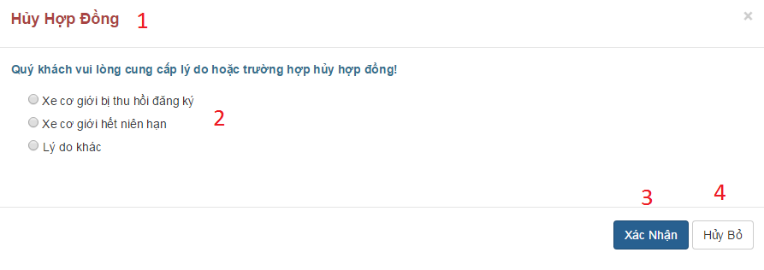

**Fields**

|  |  |  |  |  |  |  |  |
| --- | --- | --- | --- | --- | --- | --- | --- |
| **No** | **Field Name** | **Description** | **Read only** | **Mandatory** | **Control Type** | **Data Type** | **Length** |
| 1 | lblTitle | Title | Yes | Yes | Label | N/A | N/A |

**Button/Hyperlinks**

|  |  |  |  |  |
| --- | --- | --- | --- | --- |
| **No** | **Function** | **Description** | **Validation** | **Outcome** |
| 2 | chkOption cancel | Choose reason why customer cancel contract | N/A | N/A |
| 3 | btnConfirm | Confirm to cancel contract | If customer doesn’t input the reason in case they choose another reason, the system will notify. | Reload contract detail with information about contract is canceled |
| 4 | btnLeave | Leave request cancel | N/A | Return to contract detail |

1. Renew contract

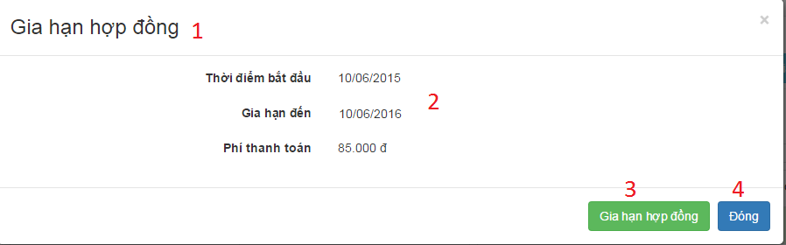

**Fields**

|  |  |  |  |  |  |  |  |
| --- | --- | --- | --- | --- | --- | --- | --- |
| **No** | **Field Name** | **Description** | **Read only** | **Mandatory** | **Control Type** | **Data Type** | **Length** |
| 1 | lblTitle | Title | Yes | Yes | Label | N/A | N/A |
| 2 | txtInformation | Information about renew contract | Yes | Yes | Label | N/A | N/A |

**Button/Hyperlinks**

|  |  |  |  |  |
| --- | --- | --- | --- | --- |
| **No** | **Function** | **Description** | **Validation** | **Outcome** |
| 3 | btnConfirm | Confirm to renew contract | N/A | Transfer to checkout page |
| 4 | btnLeave | Leave request renew | N/A | Return to contract detail |

1. Choose kind of payment

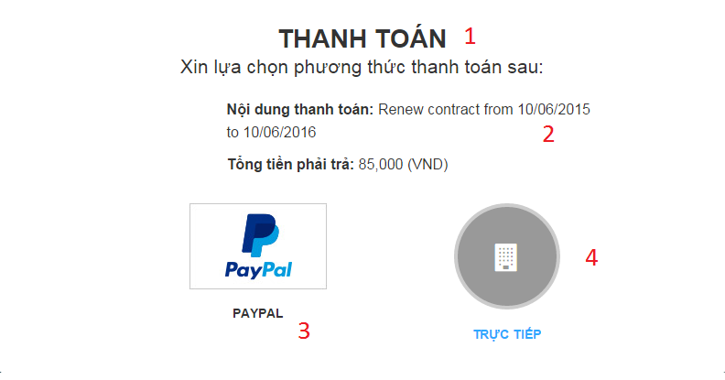

**Fields**

|  |  |  |  |  |  |  |  |
| --- | --- | --- | --- | --- | --- | --- | --- |
| **No** | **Field Name** | **Description** | **Read only** | **Mandatory** | **Control Type** | **Data Type** | **Length** |
| 1 | lblTitle | Title | Yes | Yes | Label | N/A | N/A |
| 2 | txtInformation | Information about renew contract | Yes | Yes | Label | N/A | N/A |

**Button/Hyperlinks**

|  |  |  |  |  |
| --- | --- | --- | --- | --- |
| **No** | **Function** | **Description** | **Validation** | **Outcome** |
| 3 | btnPaypal | Payment by paypal | N/A | Transfer to paypal page |
| 4 | btnDirect | Payment direct at company | N/A | Show address of list company |